TASK 4: APPLICATION ARCHITECTURE AND DATABASE CONFIGURATION
Project Title: Dockerized Book Issue and Return System
Name: Swar Sawalkar
Roll No.: 23104B0023
Department: CMPN – 4th Year
Division: C

1. Aim
To design the application architecture and database configuration for the Book Issue and Return System using Spring Boot, Java, a relational database, and Docker.
2. Objectives
- To understand the layered architecture of a Spring Boot application.
- To identify the responsibilities of controllers, services, repositories, and models.
- To design the database interaction for book management.
- To configure database connectivity.
- To prepare the application for containerized deployment using Docker.
3. Software and Technologies Used
Technology | Purpose
Java 21 | Application programming language
Spring Boot 3.4.5 | Application framework
Spring Data JPA | Database access and persistence
Hibernate | Object-relational mapping
MySQL | Relational database, if configured in the project
Maven | Build and dependency management
Docker | Application containerization
GitHub Codespaces | Cloud development environment
Note: The MySQL entry should match the actual database configured in your project.
4. Application Architecture
The Book Issue and Return System follows a layered architecture. Each layer performs a specific responsibility, making the application easier to maintain, test, and extend.
Architecture diagram
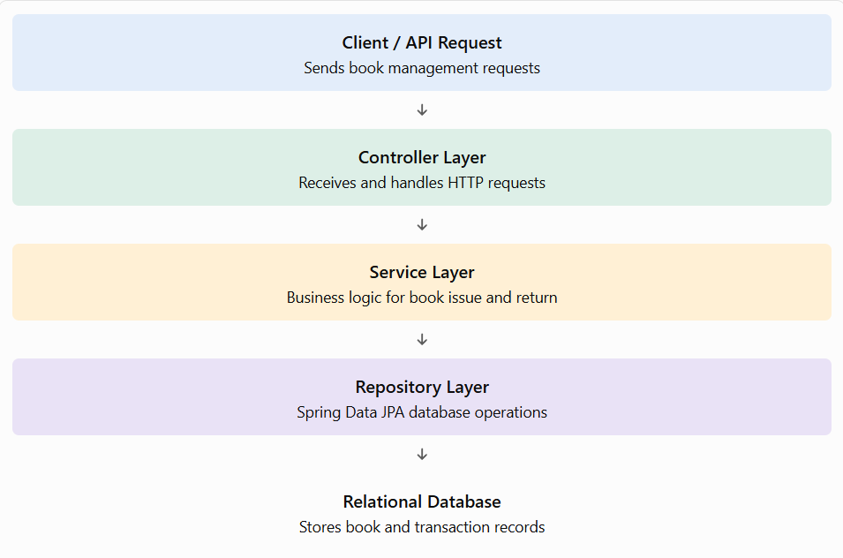
Explanation of layers:
- Controller Layer: Accepts incoming HTTP requests and returns responses to clients.
- Service Layer: Implements business rules, such as validating book availability before issuing a book.
- Repository Layer: Uses Spring Data JPA to perform database operations.
- Model Layer: Defines Java entities representing the data stored in the database.
- Database Layer: Stores book information and, if implemented, issue and return transaction records.
5. Database Design
The database stores information required to manage books and their issue/return operations.
A basic database design may contain the following tables, depending on the implemented features.
A. Book table
Field | Description
book_id | Unique identifier for each book
title | Name of the book
author | Author of the book
available | Indicates whether the book is available, if implemented

B. Issue/Return transaction table
Field | Description
transaction_id | Unique transaction identifier
book_id | Reference to the issued book
borrower_id | Identifier of the borrower, if implemented
issue_date | Date on which the book was issued
return_date | Date on which the book was returned
status | Issue or return status
The transaction table is a proposed design. Include it as an implemented table only if it exists in your project.
6. Database Connectivity Configuration
Spring Boot uses configuration properties to connect the application to the database. These properties are generally maintained in application.properties or application.yml.
Example configuration for MySQL:
spring.datasource.url=jdbc:mysql://localhost:3306/library_db
spring.datasource.username=${DB_USERNAME}
spring.datasource.password=${DB_PASSWORD}
spring.jpa.hibernate.ddl-auto=update
spring.jpa.show-sql=true
7. Docker-Based Architecture
Docker packages the Spring Boot application and its runtime dependencies into a container. If the database is also containerized, Docker Compose can manage both services.
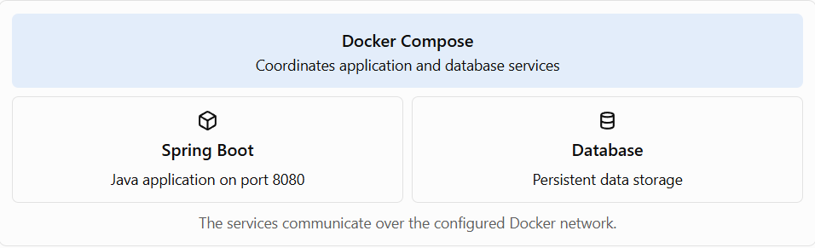
Docker Compose can define the application image, database image, environment variables, network, port mappings, and persistent storage. The actual configuration depends on the project's Dockerfile and docker-compose.yml.
8. Testing and Verification
The following commands can be used to verify the architecture and database configuration in GitHub Codespaces.
Step 1: Run the Maven tests
mvn clean test
Step 2: Inspect the Docker Compose configuration
cat docker-compose.yml
Step 3: Start the configured services
docker compose up --build -d
Step 4: Check service status
docker compose ps
Step 5: Inspect application logs
docker compose logs --tail=100
A successful configuration should allow the application to connect to its database and start without connection errors. If the logs show a database communication failure, the database service, hostname, port, credentials, and readiness should be checked.

10. Result
The layered architecture and database configuration approach for the Book Issue and Return System were documented. The design separates request handling, business logic, data access, and persistence, while Docker provides a consistent environment for application deployment.
11. Conclusion
The application architecture provides a modular structure for developing and maintaining the Book Issue and Return System. Spring Boot manages the application layers, Spring Data JPA supports database access, and Docker enables containerized execution. Correct database configuration and connectivity verification are essential for reliable application startup and operation.

